**SE3330 Course Project Iteration Planning Record**

**Iteration**: 3

**Team name**: Null Reference Exception

**Team Leader**: Ryan Wolff

**Date**: 4/11/2019

1. **Sprint Backlog: (a screen shot of your sprint backlog)**

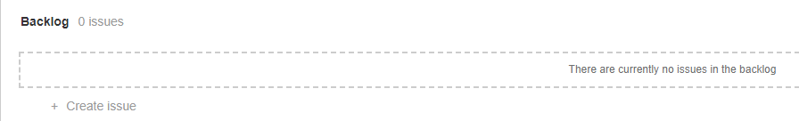

1. **Task breakdown:**

|  |  |  |  |
| --- | --- | --- | --- |
| Story ID | Tasks | Assigned to | Estimated Time |
| NRE-14 | Store procedure for creating a chatroom with only two people in it. | Mitch | 4 |
| The user should be able to double click a name to go to a direct message chatroom. |
| The server and database should know the difference between a chatroom and a DM chatroom. |
| NRE-21 | Make a drop down element to switch themes | Austin | 3 |
| Change the colors of the UI based on the theme selected |
| NRE-13 | Have the server query the SQL database for previous messages and send them to the client. | Ryan, Mitch | 4 |
|  |
| NRE-25 | Create a help text for each command in the server | Ryan | 1 |
|  |
| NRE-61 | Create a sproc for editing the chatroom's password. | Austin, Mitch, Liam | 3 |
| The user should be able to click a drop down menu and enter a new password in a dialog box |
| NRE-59 | A sproc should create a new entry for a chatroom | Mitch, Liam | 5 |
| The user will be prompted for a name and password for their new chat. |
| NRE-64 | The chatroom area will prompt for a password to be sent using the message-box. | Austin, Ryan | 2 |
| NRE-63 |  | Austin | 2 |
| NRE-62 |  | Austin | 2 |

1. **Individual Assignment Summary**

|  |  |  |
| --- | --- | --- |
| Team Member | Assigned Tasks (ID) | Total estimated time |
| Ryan | 13, 25, 64 | 7 |
| Austin | 62, 63, 64, 61, 21 | 12 |
| Mitch | 14, 13, 61, 59 | 16 |
| Liam | 59, 61 | 8 |